The Northern Virginia Radio Control Club
&
West Potomac High School STEM Program

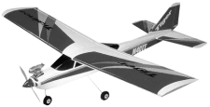
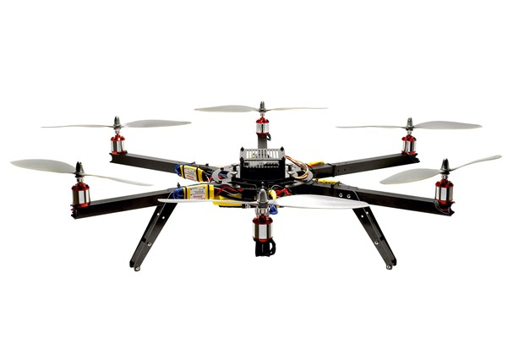
Auction
Saturday, October 21, 2017
at
West Potomac High School
6500 Quander Road, Alexandria Virginia, 22307
(Auction in Main Gym – Use Door #13 for entrance)
Setup and Viewing 8-10 a.m. – Auction Starts at 10 a.m.

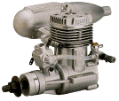R/C Airplanes, Drones, Helicopters, Cars, Boats, Parts
Buy and/or Sell

Auction Tags Provided
Fixed-Price Tables Available

Admission and Door Prize Entry- $5
$20 Auction Minimum; Fixed Price Table, No Minimum
10% of All Sale Proceeds to Club; Computerized Accounting
Credit Cards Accepted
NO PRIVATE SALES
Food and Drink Available For Purchase

